

The information security policy

Version 1.1

May 2023
Last Revised February 2024

Revision history

Version No, Date | Content | Name of person
May 2023 – draft proposal | Main description | Fedor Bogorodskiy Bogorodskaya
February 2024 – v.1.0 | Update | Fedor Bogorodskiy Bogorodskaya

Development team

Author: Fedor Bogorodskiy Bogorodskaya
Expert: Natalia Bogorodskaya
Editor: Fedor Bogorodskiy Bogorodskaya
Approved by: Nicolas Dotti
Contents

1. Preamble 4
1.1 Development Team 4
1.2 Goals and Objectives 4
1.3 Goals and Objectives 4
1.4 Mandatory Compliance 5
2. Purpose 5
2.1 Audience 5
3. Policy 6
3.1 Security Guiding Principles 6
3.2 Principal PCI 4.0 requirements 8
3.3 Risk assessment procedure 9
3.4 Hierarchy of policies, guidelines and job instructions 9
3.5 Users 10
3.6 Limits and Exceptions 10
3.7 Roles and responsibilities 10
3.8 Language policy 14
3.9 List of technical policies (all E) 14
3.10 List of combined policies/guidelines (all E) 14
3.11 List of standards and guidelines (all E) 14
3.12 Technical Policy template 15
3.13 Standard and guideline template 15
3.14 Provider and contractor relations 15
4. Migom Bank employee awareness program 15
4.1 Policy 15
4.2 Awareness/Training/Education model 16
4.3 Program and responsibilities 17
5. Enforcement 17
5.1 Sanctions and violations 17
6. Revision cycle 18
6.1 Life cycle 18
6.2 Policy numeration agreement 18
6.3 Contacts 19

Preamble

Development Team
Current development team of this document consists of two groups of BLOX PAYMENTS SOLUÇÕES EM MEIOS DE PAGAMENTOS LTDA (further – BLOX) Information security team, responsible for development of this document and compliance with mandatory standards and group of various Experts giving advice on the subjects of Networking, Data protection, Legal, Human Resources and company daily operations.
Information Security:
- Writing/Compliance/Distributing – Fedor Bogorodskiy Bogorodskaya (Chief Operation Officer - COO)
- Establishing/Editing/Compliance – Vladislav Klimenko (Chief Technological Officer – CTO),
- General director – Nicolas Dotti (Chief Executive Officer - CEO)
Experts:
- Applied systems testing and implementation –Konstantin Shmelev
- Daily operations – Fedor Bogorodskiy Bogorodskaya (COO)
- IT security – Mstislav Vladislav Klimento (CIO)

Goals and Objectives
The major goal of this document is to communicate and clarify management position on security and high-level security principles.
Current objectives of this General (Governing) Security Policy are as follows:
- Describe and set up company security principles
- Inform readers on information security standards
- Inform readers on mandatory compliance and its principles
- Describe the hierarchy of security policies, guidelines, guides and job instructions
- Describe roles and responsibilities
- Implement templates for lesser policies, guidelines, guides and job instructions
- Define and authorize the consequences of violation
- Describe security policy maintenance and life cycle
- And in general – Help minimize risk
In other words, the goal of this document is to setup frame for company security documents.
This document does not cover any company business related subjects.

Goals and Objectives
The following security standards were used and kept in mind while developing the current security policy:
- ISO/IEC 17799:2005 Information technology — Security techniques — Code of practice for information security management
- ISO/IES 27000 series
- OWASP
- PCI DSS v.4.0
- BS ISO/IEC 17799:2000 / BS 7799-1:2000
- NIST SP800-53 Guide for Assessing the Security Controls in Federal Information Systems and Organizations, Building Effective Security Assessment Plans
- NIST SP 800-12 An Introduction to Computer Security
- NST SP 800-30 Risk Management Guide for Information Technology Systems
- CERT OCTAVE-S
- CERT OCTAVE Criteria, Version 2.0
- CERT OCTAVE Catalog of Practices, Version 2.0
- NIST 800-50: Security Awareness and Training Program
- NIST 800-16: Information Technology Security Training Requirements.

Mandatory Compliance
BLOX is a Company and we plan to start working with MasterCard and Visa, issuing and acquiring cards of MasterCard and VISA. To certify that status and continue our business we should comply with the security rules established by MasterCard and Visa.
In 2016 major international card companies - American Express, Discover Financial Services, JCB International, MasterCard Worldwide, and Visa Inc. have agreed to develop unified formal security standards (called Payment Card Industry Security Standards) and to incorporate them as the technical requirements of each of their data security compliance programs. To achieve this goal, they formed a council called Payment Card Industry (PCI) Security Standards Council in form of open global forum as a party to be responsible of the development, management, education, and awareness of the PCI Security Standards.
In conclusion, we should MANDATORY comply with following PCI Standard:
- Payment Card Industry Data Security Standard VERSION 4.0
Also, we must enforce all our agents, clients and vendors to support the same standard when applicable. In case they already support that standard, we should establish a process of regular verification of their PCI compliance status.
Also, we must enforce all our vendors to support following standard
- Payment Application Data Security Standard (PCI-SSF).

Purpose
The primary purpose of this policy is to inform users, management and staff of essential requirements for protecting various assets, including people, hardware, software and data.

Audience
This policy should be read by everyone who has “logical” or “physical and logical” access to customer data and information, and/or operational environment, and most of staff who has only “physical” access to operational environment. This includes all permanent (full working) management and operational staff, and most of full-working technical staff excluding cleaning services and physical security staff also.
List of policy users and policy user positions according to roles are described in this document.
This document is CONFIDENTIAL. It means that it can be provided on a need-to-know basis only to properly identified persons, in all of its forms and on all media, during all phases of its life, so that it cannot be compromised or released to any unauthorized person.

Policy

Security Guiding Principles
Our most basic principle is to protect the confidentiality, integrity and availability of customer information.

AVAILABILITY

INTEGRITY

CONFIDENTIALITY
Only shared
Among authorized
Persons of Organization
Authentic and complete
Sufficiently accurate
Trustworthy and reliable
Accessible
When needed
By those who need it
Diagram 1. High-level information security guiding principles or CIA triad

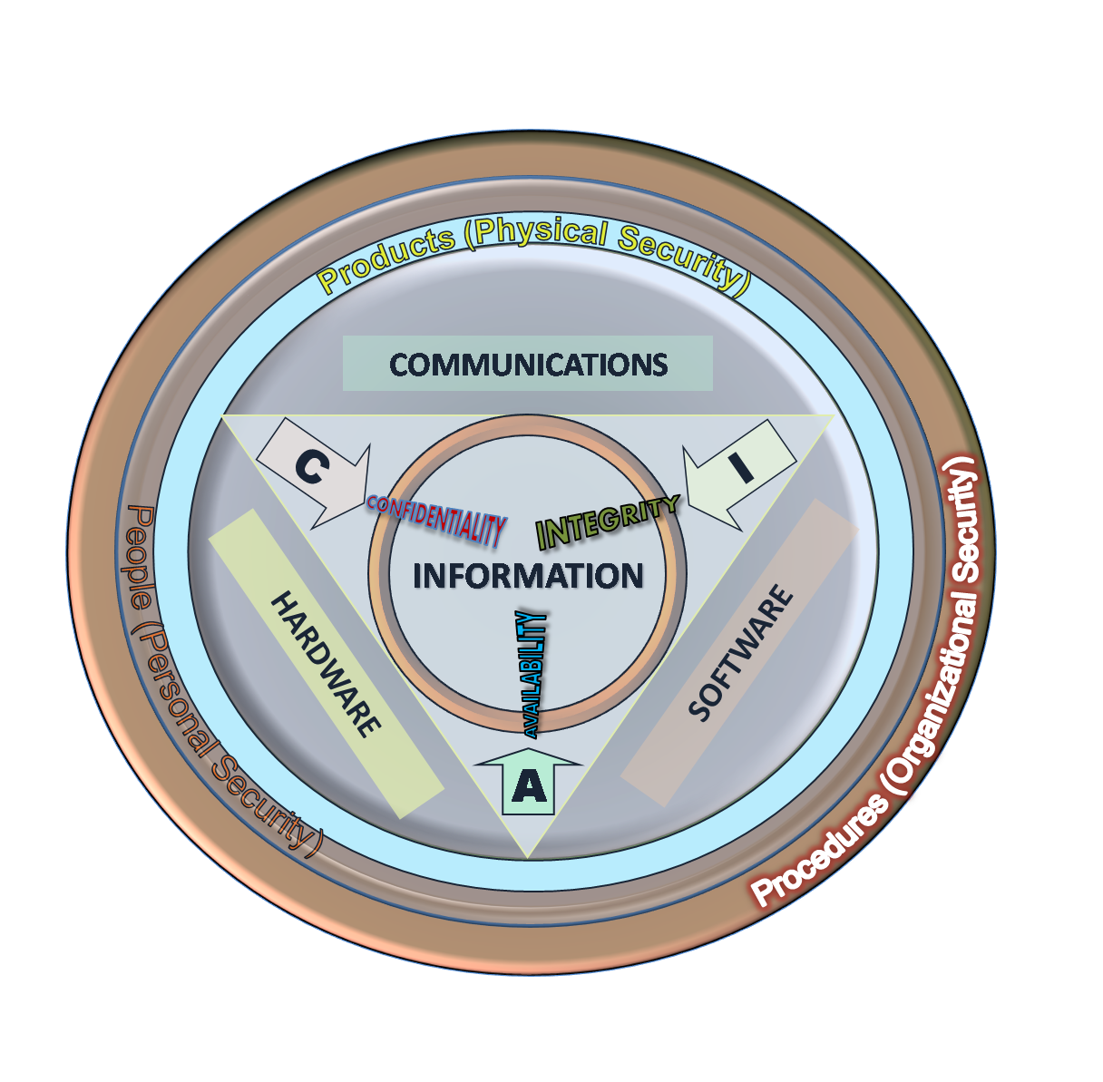

Picture 1. CIA triad in more general form
Confidentiality
is the term used to prevent the disclosure of information to unauthorized individuals or systems.
For example, a credit card transaction on the Internet requires the credit card number to be transmitted from the cardholder to the merchant and from the merchant to a transaction processing network. The system attempts to enforce confidentiality by encrypting the card number during transmission, by limiting the places where it might appear (in databases, log files, backups, printed receipts, and so on), and by restricting access to the places where it is stored. If an unauthorized party obtains the card number in any way, a breach of confidentiality has occurred.
Breaches of confidentiality take many forms. For example – permitting someone to look over your shoulder at your computer screen while you have confidential data displayed on it could be a breach of confidentiality.
Confidentiality is necessary (but not sufficient) for maintaining the privacy of the people whose personal information a system holds.
Integrity
In information security, integrity means that data cannot be modified undetectably. Integrity is violated, for example, when a message is actively modified in transit. Information security systems should provide message integrity in addition to data confidentiality.
Availability
For any information system to serve its purpose, the information must be available when it is needed. This means that the computing systems used to store and process the information, the security controls used to protect it, and the communication channels used to access it must be functioning correctly. High availability systems aim to remain available at all times, preventing service disruptions due to power outages, hardware failures, and system upgrades. Ensuring availability also involves preventing denial-of-service attacks.
In Authenticity
e-Business and information security it is necessary to ensure that the data, transactions, communications or documents (electronic or physical) are genuine. It is also important for authenticity to validate that both parties involved are who they claim they are.
Non-repudiation
In law, non-repudiation implies one's intention to fulfill their obligations to a contract. It also implies that one party of a transaction cannot deny having received a transaction nor can the other party deny having sent a transaction.
So, technologies such as digital signatures and encryption should be implemented to establish authenticity and non-repudiation.
BLOX guiding principles:
- Everyone is responsible for security
- All users and entities are authenticated
- Principle of “least access” is appropriately applied
- Risk exposure is balanced with the cost of risk mitigation
- Security measures are proactively implemented
- We will promote information classification, awareness and governance
- PCI DSS Industry standard is our major security document. Compliance with it is mandatory
- We will adopt other security industry standards where appropriate
- We will treat customer data with the highest level of confidentiality and will never share this information with third parties without permission
- We will evolve the practice of information security with our external and internal customers (Best practice sharing on standards, solutions architecture, technology, processes and policies)
- Daily/Monthly/Yearly/Monthly/Annually routines must be strictly followed by responsible personnel

Principal PCI 4.0 requirements
PCI DSS sets a minimum set of requirements for protecting cardholder data. BLOX must strictly follow the following PCI security requirements:
- Build and Maintain a Secure Network and Systems
- Requirement 1: Install and Maintain Network Security Controls.
- Requirement 2: Apply Secure Configurations to All System Components.
- Protect Account Data
- Requirement 3: Protect Stored Account Data.
- Requirement 4: Protect Cardholder Data with Strong Cryptography During Transmission Over Open, Public Networks.
- Maintain a Vulnerability Management Program
- Requirement 5: Protect All Systems and Networks from Malicious Software.
- Requirement 6: Develop and Maintain Secure Systems and Software.
- Implement Strong Access Control Measures
- Requirement 7: Restrict Access to System Components and Cardholder Data by Business Need to Know.
- Requirement 8: Identify Users and Authenticate Access to System Components.
- Requirement 9: Restrict Physical Access to Cardholder Data.
- Regularly Monitor and Test Networks
- Requirement 10: Log and Monitor All Access to System Components and Cardholder Data.
- Requirement 11: Test Security of Systems and Networks Regularly.
- Maintain an Information Security Policy
- Requirement 12: Support Information Security with Organizational Policies and Programs.
Due to the fact that BLOX has business need to store Primary Account Number and other cardholder data, following principles of cardholder data protection must be followed:
Cardholder data | Permitted to store | Render Stored Account Data  Unreadable
Primary Account Number (PAN) | YES | YES
Cardholder Name | YES | NO
Service Code | YES | NO
Expiration Date | YES | NO
Sensitive Authentication Data | NO
Full Magnetic Stripe Data | NO
CAV2/CVC2/CVV2/CID | NO
PIN/PIN Block | NO

Risk assessment procedure
BLOX internal Risk assessment procedure is based on OCTAVE-S method developed by Carnegie Mellon Software Engineering Institute.
Octave-S method was chosen because it is strategically, self-directed, technology-independent, scalable to small companies and is among mentioned in PCI DSS guiding documents.

Hierarchy of policies, guidelines, and job instructions
Despite the fact that BLOX is not big organization we implemented full 3-step hierarchy of policies – Governing policy (this document) – Technical policies (separate policies on various security aspects) – Guidelines and standard (current practices and direct instructions to staff positions).
In simple words, governing policy answers to the question “WHY?”, technical policy gives answer to the questions “Who, When and Where?”, and standard answer to question “How?”
Major reason of such hierarchy – harmonizing policy structure with ISO standards.
Governing policy
Technical policy
Technical policy
Technical policy
……
Guideline
Standard
Guideline
Guideline
Standard
Standard
Diagram 2. Policy hierarchy

Users
From security point of view BLOX staff is divided into three major categories: Management, Operational and Technical.
Operational and Technical categories are divided in several logical blocks related to performed roles. This categorization and division are not fully equal to organizational structure of the company. The company positions are not always equal to roles. Formal company hierarchy also is not reflected in this division. Reasons for this difference include principle of keeping number of employees as small as possible for normal company functioning and current country labor laws. Special table of mapping current employees with positions to company security roles is presented in Appendix B of the following format:
Roles | Role 1 | Role 2 | Role 3 | Role 4 | Role 5
Title | P|S|C|I | P|S|C|I | P|S|C|I | P|S|C|I | P|S|C|I
Person
Roles description:
P – primary responsible
S – secondary
C – consulting
I – informed
Mandatory users of this policy are all Management and Operational staff. Most positions in Technical staff are also mandatory users of this policy.

Limits and Exceptions
According to the declared security principle of “least access” several lesser positions in Technical staff receive only “job guides” and thus are not users of this policy. These positions now include cleaning staff and physical security guards in the Maintenance logical bloc.

Roles and responsibilities
Guided by the “minimum necessary staff” principle we declare list of roles in List 1 active:
List 1. BLOX security Roles:
Management
Chief Executive Officer or General Director (CEO)
Chief information Officer or IT Director (CIO)
Chief Processing Officer (CPO)
Chief Operational Officer (COO)
Chief Financial Officer (CFO)
Chief Security Officer (CSO)
Chief Internal Audit and Compliance (CIACO)
Operational
Business operations:
Applied Systems Administrator
Applied Systems Client Support
Applied Risk Manager
Accounting and finance
Accountant
Risk management
Charge back and dispute manager
Bank and payment system rules compliance manager
Technical
System development
Applied systems developer (e-commerce)
Applied systems testing and implementation (e-commerce)
Applied systems developer (processing)
Applied systems testing and implementation (processing
Applied systems developer (card issuing/personalisation)
Applied systems testing and implementation (card issuing/personalisation)
System administration
Network administrator
System administrator
System administrator
Database administrator
System support
Duty system support
Infrastructure support
Security
1st security officer
2nd security officer
3^{d} security officer
Custodian
Custodian
Security system operator
Internal audit
Audit and compliance manager
Business continuity/workplace safety manager
Maintenance
Physical guard
Cleaning service
Office support
Office manager
Current roles responsibilities are presented in Table 1. Only responsibilities related to security issues are presented in table.
Table 1. Roles – responsibilities
Role | Responsibilities
Chief Executive Officer | - business strategy development and maintenance  - marketing strategy development and maintenance  - human resources management  - legal support  - corporate relations  - financial planning
Chief Information Officer | - company information technology infrastructure development and maintenance including all networking, software and hardware structures  - managing applied systems development and maintenance  - systems monitoring  - hardware and software systems updating following PCI DSS requirements
Chief Operational Officer | - daily business operations support including all customer relations and support  - documentation development and distribution  - security procedures implementation and control  - business statistics and analysis  - managing of logical access to customer data systems
Chief Processing Officer | - processing infrastructure development, implementation and maintenance including all application systems  - issuing procedures management  - issuing operators management
Chief Financial Officer | - financial reports  - financial record keeping  - chief accountant  - financial expertise
Chief Security Officer | - Establishing security policy, rules and procedures  - first security officer  - security alarm monitoring  - security compliance maintenance  - management of facility maintenance services (including guarding)  - managing of physical access systems  - facility business continuity support
Chief Internal Audit and Compliance | - overseeing and managing compliance  - development and maintenance of risk management procedures  - managing relations with external audit
Applied Systems Administrator | - managing applied systems user access and registrations
Applied Systems Client Support | - guiding and supporting applied system clients  - gather customers error reports and suggestions  - managing bug fixing and new functions implementations program
Applied Systems Operator | - performing daily system tasks including new registrations, limits etc.  - primary statistical analysis and reports  - primary fraud suspect monitoring
Applied Risk Manager | - performs primary client compliance checking  - gather client applications and required documents
Accountant | - daily accounting duties
Charge back and dispute manager | - fraud monitoring and prediction  - chargeback and dispute management
Bank and payment system rules compliance manager | - monitoring payment system rules changing  - monitoring banking rules changing  - implementing new internal payment system compliance rules
Applied systems developer | - applied systems development
Applied systems tester and implementer | - new version of applied systems and bug fixes testing  - supporting testing environment  - new versions, patches and bug fixes deployment
Network administrator | - company network administration and configuration management  - network business continuity support
System administrator | - operating systems installation management and support  - database installation management and support
Database administrator | - administrates company databases, including PCI DSS relevant  - have exclusive access to databases
Duty system support | - daily software systems business continuity and support (including applied systems)  - daily hardware business continuity support  - daily internal software and hardware support
Infrastructure support | - support system hardware (in all means)
2nd security officer | - managing of logical access systems  - facility business continuity support
3^{d} security officer | - facility business continuity support  - managing of physical or logical access systems in absence of 1st or second security officers
Custodian | - keys management procedures
Security systems operator | - physical access monitoring  - logical access reports monitoring
Audit and compliance manager | - system logs analyzing and audit  - access lists analyzing and audit  - configurations audit  - performing internal network penetration tests
Business continuity/workplace safety manager | - responsible for fire alarms, safety exits, fire control system, flood pump etc  - control on workplace safety awareness
Physical guard | - guarding facilities and equipment
Cleaning service | - keeping facilities clean
Office manager | - support employees with everyday office needs, including phone/fax/copier support  - keeps document archive (excluding accounting and PCI DSS documents)

Language policy
Due to mandatory compliance with PCI DSS to ease eternal audit procedures all technical policies and guidelines are written in English. Some technical policies and guidelines are translated to Spanish to ease personnel understanding.
Due to fact that most of personnel native languages are Russian and Latvian all job instructions are written in personnel native languages. Some job instructions are translated to English by request of external audit.
In lists of policies language availability is written in brackets where E – means English, S – Spanish.
Note: following list are not full. Only policies and standards necessary for PCI audit listed.

List of technical policies (all E)
- Network policy
- Configuration management policy
- System administration policy
- Cardholder data protection policy
- Media storage policy
- Employee-facing technology policy

List of combined policies/guidelines (all E)
- Wireless network policy and configuration standard
- Notebook and mobile devices with wireless access policy and user guidelines
- Data access (control) policy and standard
- Physical access policy and procedures

List of standards and guidelines (all E)
- Risk assessment procedure
- Incident response plan
- Human resource management guidelines
- Internal audit guidelines
- Applied software development guidelines
- Cardholder data protection standard
- Applied system administration guidelines
- System administration standard
- Firewall and router configuration standard
- List of third-party providers

Technical Policy template
Following template for technical policies s suggested:
- Purpose. Describes documents purposes. Defines documents audience.
- Scope. Defines security objects, frames of policy application. Defines exceptions.
- Policy. Defines responsibilities “who”, “when” and “where”. Defines prohibitions. Defines audit objects.
- Enforcement. Defines penalties for policy violations.
- Definitions (optional). Vocabulary and explanations of used terms.
- Revision history.

Standard and guideline template
Following template for job instructions and guidelines is suggested:
- Users. Who should read this instruction.
- Scope. Defines protection elements.
- Instructions (guides). List of instructions, configurations, guides etc.
- Enforcement. Defines penalties for violations.
- Definitions (optional). Vocabulary and explanations of used terms.
- Revision history.

Provider and contractor relations
BLOX do not share any personal/cardholder data with any contractors and do not hire any third-party companies for performing any tasks.
BLOX Security Officers regularly checks PCI status of all contracted companies.
(In Provider list document).

BLOX employee awareness program

Policy
- All individuals must be appropriately trained in how to fulfill their security responsibilities before allowing them access to the system.
- Systematic and periodic refresher training required for continued access to the system.
- All individuals must receive specialized training focused on their responsibilities and the application rules, before allowing access to the application.
- Chief Security Officer has a responsibility to ensure that the company has trained personnel sufficient to assist the company in complying with required policies, procedures, standards, and guidelines.
- Chief Audit and Compliance Officer has the authority to ensure compliance with the requirements imposed on the company, including training and oversee personnel with significant responsibilities for information security.
- Multiple methods of communicating awareness and educating employees must be implemented. (BLOX currently practices - posters, meetings, group seminars, individual security training)
- Company wide information security program must include security awareness training to inform personnel, contractors and other users of information systems that support the operations and assets of the company, of:
      - information security risks associated with their activities; and
      - their responsibilities in complying with company policies and procedures designed to reduce these risks

Awareness/Training/Education model
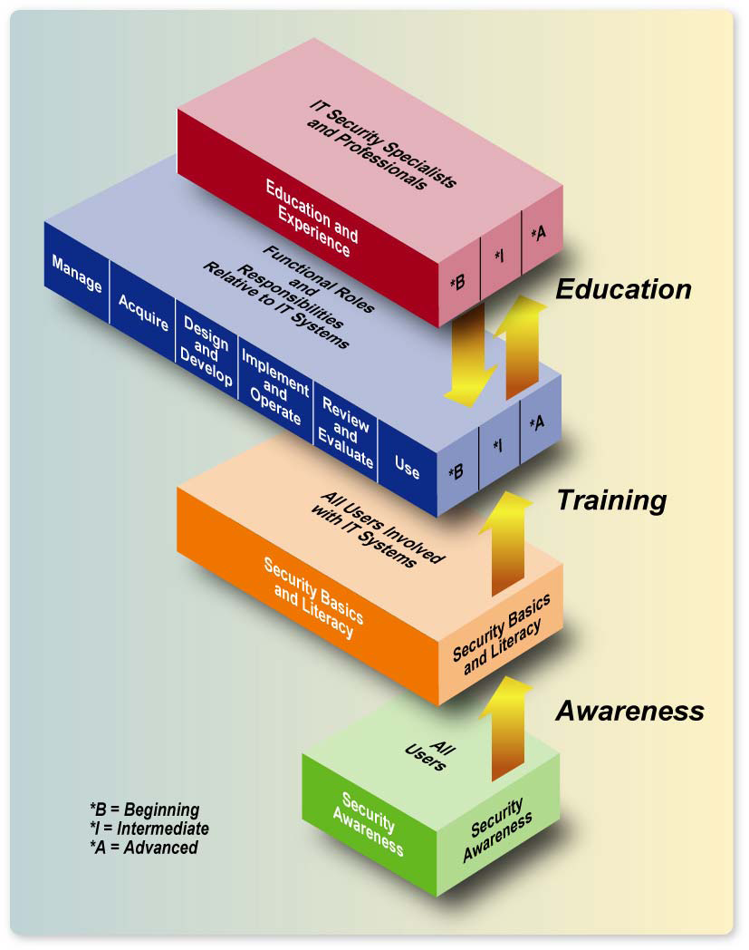
BLOX accepts A Role- and Performance-Based Security Training Model (described in NIST 800-16/NIST 800-50) a basic company awareness training model.
Pic. 2 Learning continuum
According to this model:
- Awareness is not training. The purpose of awareness presentations is simply to focus attention on security. Awareness presentations are intended to allow individuals to recognize IT security concerns and respond accordingly.
- Training strives to produce relevant and needed security skills and competencies.
- Education integrates all of the security skills and competencies of the various functional specialties into a common body of knowledge .and strives to produce IT security specialists and professionals capable of vision and pro-active response.

Program and responsibilities
Due to the fact that BLOX is not big company and located only in one place – centralized management awareness training model is used.
Chief Security Officer and Chief Operation Officer are responsible for strategy development, planning, and scheduling of program.
CIO, CPO and COO are responsible for detailed specialist training.
Everyone is responsible for self-education.
Following awareness training courses are planned:
“IT security basics and company security policy” is an instructional awareness seminar for all new employees. One day.
- responsible CIO (COO in absence)
“New in general IT security” is seminar for all employees hold once per year. 4 hours.
- responsible COO (CIO in absence)
PCI DSS compliance. PCI changes and proposals” is seminar for all employees hold once per year. One day.
- responsible COO
List of recommended security literature.
- responsible COO

Enforcement

Sanctions and violations
Following hierarchical system of disciplinary actions is implemented and in place:
- including in company security violation notification public list
- termination of employment
- court action against terminated employee
Every technical policy, job guide and instructions describes sanctions for violations of that policies.
At the same time every company employee signs Non Disclosure Agreement with described legal actions in case of security breach.
List of corresponding labor laws:
Violation of current security policy will cause “including in company security violation notification public list”.

Revision cycle

Life cycle
Life cycle described in this chapter applies also to all underlining technical policies, guidelines and job instructions.
New revisions of policy are issued on following circumstances:
- expiration of policy (one year since internal approval)
- new regulatory compliance
- new company project roll-outs
- new technology implemented
- user requests
- editorial suggestions
Change request
New policy
Writing new policy
Team review
Consulting review
Update other language policies
Update corresponding policies
Revised policy
Policy updating
Editorial changes
Publish communicate implement
Team decision ?
Intend change?
Approved ?
Write new
Yes
No
Update
No
Yes
Diagram 2. Policy revision cycle scheme
Requests to revise policy are accepted by policy development team.
Team analyzes the request and make a decision if a revision or a new policy needed.
In case of significant changes policy is revised by team of consultants including security specialist, human resources specialist and legal specialist.
After consultants approval policy is published and communicated to users.

Policy numeration agreement
All updates within a year – numeration after dot keeping main number the same.
Annual update leads to change main number.

Contacts
Policy development team accept all questions formal suggestions by e-mail:
docs@bloxpayments.com.

